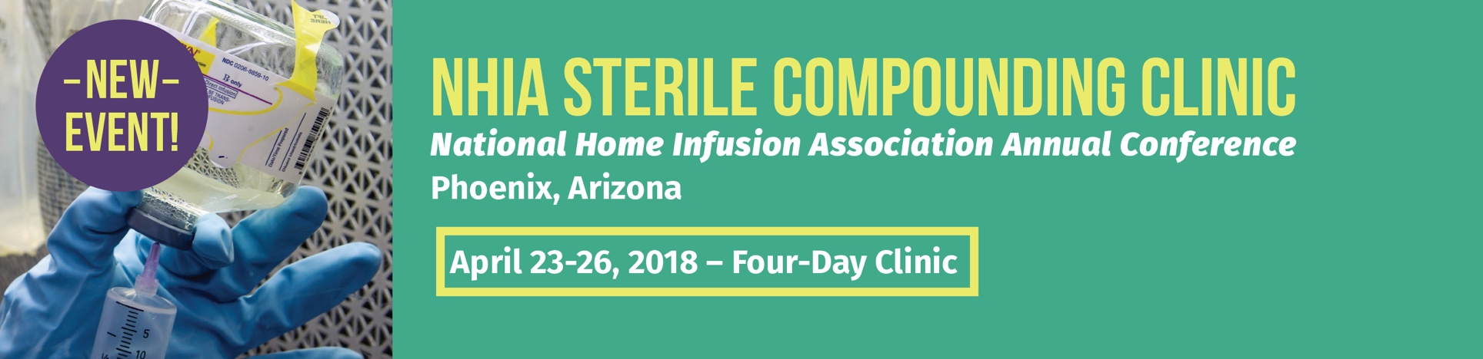

Dear
I am writing to request your approval to attend the Sterile Compounding Clinic being held at the 2018 NHIA Annual Conference in Phoenix, Arizona from April 23-26, 2018—the nation’s premier gathering of home and specialty infusion professionals and experts.
This interactive, four-day program combines classroom learning with hands-on, lab-based training to provide sterile compounding professionals with the most current information and practices pertaining to sterile compounding standards and methods. Space is limited; however, NHIA will reserve my place with a $200 refundable deposit, now through December 31. I am requesting your permission to reserve a spot. The deposit will be credited toward the total admission fee that is due by February 1, 2018.

The clinic is designed especially for pharmacy technicians, pharmacists, nurses, and physicians to deliver comprehensive sterile compounding training for home and specialty infusion. In addition to an on-site Simulated Compounding Lab to facilitate hands-on learning and skills observations by qualified experts, the Clinic will provide an in-depth review of currently adopted USP standards and how to meet them, the FDA’s role in regulating sterile compounding in 503A pharmacies, and 40 ACPE-approved CE hours.
Registration includes access to all NHIA Annual Conference general sessions and keynotes, networking opportunities, and the 2018 NHIA Exhibit Hall with more than 100 companies showcasing the industry’s latest products and technologies.
I plan to return with a heightened knowledge about our industry, valuable strategies and best practices, and the confidence I need to move beyond memorizing “compliance rules” to applying real-world knowledge and skills that will benefit our organization.
I would appreciate your consideration and look forward to receiving your approval to attend.

Sincerely,

(Your Name)

